Practical No.1
Aim :- Design and develop location based messaging app

UI Code :-

<?xml version="1.0" encoding="utf-8"?>

<RelativeLayoutxmlns:android="http://schemas.android.com/apk/res/android"
xmlns:tools="http://schemas.android.com/tools"
android:layout_width="match_parent"
android:layout_height="match_parent"
android:paddingBottom="@dimen/activity_vertical_margin"
android:paddingLeft="@dimen/activity_horizontal_margin"
android:paddingRight="@dimen/activity_horizontal_margin"
android:paddingTop="@dimen/activity_vertical_margin"
tools:context="com.example.prashant.locationmsg.MainActivity">

<TextView
android:layout_width="wrap_content"
android:layout_height="wrap_content"
android:textAppearance="?android:attr/textAppearanceLarge"
android:text="Large Text"
android:id="@+id/textView"
android:layout_alignParentLeft="true"
android:layout_alignParentStart="true" />

<TextView
android:layout_width="wrap_content"
android:layout_height="wrap_content"
android:textAppearance="?android:attr/textAppearanceLarge"
android:text="Large Text"
android:id="@+id/textView3"
android:layout_below="@+id/textView"
android:layout_alignParentLeft="true"
android:layout_alignParentStart="true"
android:layout_marginTop="96dp" />

<Button
android:layout_width="wrap_content"
android:layout_height="wrap_content"
android:text="Get Longitude and Latitude"
android:id="@+id/button"
android:layout_centerVertical="true"
android:layout_alignParentLeft="true"
android:layout_alignParentStart="true" />

<TextView
android:layout_width="wrap_content"
android:layout_height="wrap_content"

android:textAppearance="?android:attr/textAppearanceLarge"
android:text="Large Text"
android:id="@+id/textView2"
android:layout_alignParentBottom="true"
android:layout_alignRight="@+id/button"
android:layout_alignEnd="@+id/button" />
</RelativeLayout>

Source Code:-

package com.example.prashant.locationmsg;
import android.Manifest;
import android.content.Context;
import android.content.pm.PackageManager;
import android.location.Location;
import android.location.LocationListener;
import android.location.LocationManager;
import android.net.Uri;

import android.support.v4.app.ActivityCompat; import android.support.v7.app.AppCompatActivity; import android.os.Bundle; import android.util.Log;

import android.view.View;
import android.widget.Button;
import android.widget.TextView;

import com.google.android.gms.appindexing.Action;
import com.google.android.gms.appindexing.AppIndex;
import com.google.android.gms.common.api.GoogleApiClient;

public class MainActivityextendsAppCompatActivityimplementsLocationListener {
TextViewt1, t2, t3;
Button b1;
protected LocationManagerlocationManager;
protected LocationListenerlocationListener;
double lat, longg;
/**
- ATTENTION: This was auto-generated to implement the App Indexing API.
- See https://g.co/AppIndexing/AndroidStudio for more information.
*/

private GoogleApiClientclient;

@Override

protected void onCreate(Bundle savedInstanceState) { super.onCreate(savedInstanceState); setContentView(R.layout.activity_main);

t1 = (TextView) findViewById(R.id.textView);
t2 = (TextView) findViewById(R.id.textView3);
t3 = (TextView) findViewById(R.id.textView2);

b1 = (Button) findViewById(R.id.button);

b1.setOnClickListener(new View.OnClickListener() { @Override

public void onClick(View view) {
t1.setText("Latitude = " + lat);
t2.setText("Longitude = " + longg);

if (lat<38 &&lat>36 &&longg<122 &&longg>118) { t3.setText("In-Side The Area");

} else {
t3.setText("Out-Side The Area");
}
}
});

locationManager= (LocationManager) getSystemService(Context.LOCATION_SERVICE);
if (ActivityCompat.checkSelfPermission(this,
Manifest.permission.ACCESS_FINE_LOCATION) !=
PackageManager.PERMISSION_GRANTED&&ActivityCompat.checkSelfPermission(this,Manifest.permission.ACCESS_COARSE_LOCATION) !=
PackageManager.PERMISSION_GRANTED) {
- TODO: Consider calling
  - ActivityCompat#requestPermissions
  - here to request the missing permissions, and then overriding

  - public void onRequestPermissionsResult(intrequestCode, String[] permissions,
// int[] grantResults)

    - to handle the case where the user grants the permission. See the documentation
    - for ActivityCompat#requestPermissions for more details.

return;
}

locationManager.requestLocationUpdates(LocationManager.GPS_PROVIDER, 0, 0, this);

- locationManager.requestLocationUpdates(LocationManager.GPS_PROVIDER, 0, 0, this);
  - ATTENTION: This was auto-generated to implement the App Indexing
API.

  - See https://g.co/AppIndexing/AndroidStudio for more information.

client = new GoogleApiClient.Builder(this).addApi(AppIndex.API).build();
}

@Override

public void onLocationChanged(Location location) {

- txtLat = (TextView) findViewById(R.id.textview1);
lat= location.getLatitude();

longg= location.getLongitude(); Log.d("" + lat, "" + lat); Log.d("" + longg, "" + longg);

if (lat== 38 &&longg== 118) {
t3.setText("You Are at Perfect Place !!!!");
} else {
t3.setText("You are not at Perfect Place !!!!");
}

//t1.setText("Latitude:" + location.getLatitude() + ", Longitude:" + location.getLongitude());
}

@Override

public void onProviderDisabled(String provider) { Log.d("Latitude", "disable");
}

@Override

public void onProviderEnabled(String provider) { Log.d("Latitude", "enable");
}

@Override

public void onStatusChanged(String provider, intstatus, Bundle extras) { Log.d("Latitude", "status");
}
@Override

public void onStart() {
super.onStart();
ATTENTION: This was auto-generated to implement the App Indexing API.

  - See https://g.co/AppIndexing/AndroidStudio for more information.
client.connect();

Action viewAction = Action.newAction( Action.TYPE_VIEW, // TODO: choose an action type.
"Main Page", // TODO: Define a title for the content shown.

- TODO: If you have web page content that matches this app
activity's content,
- make sure this auto-generated web page URL is correct.
- Otherwise, set the URL to null.

Uri.parse("http://host/path"),
// TODO: Make sure this auto-generated app URL is correct.

Uri.parse("android-app://com.example.prashant.locationmsg/http/host/path")
);

AppIndex.AppIndexApi.start(client, viewAction);
}

@Override

public void onStop() {

super.onStop();

- ATTENTION: This was auto-generated to implement the App Indexing API.

  - See https://g.co/AppIndexing/AndroidStudio for more information.
Action viewAction = Action.newAction(

Action.TYPE_VIEW, // TODO: choose an action type.
"Main Page", // TODO: Define a title for the content shown.

    - TODO: If you have web page content that matches this app
activity's content,
    - make sure this auto-generated web page URL is correct.
    - Otherwise, set the URL to null.

Uri.parse("http://host/path"),
// TODO: Make sure this auto-generated app URL is correct.

Uri.parse("android-app://com.example.prashant.locationmsg/http/host/path")
);

AppIndex.AppIndexApi.end(client, viewAction); client.disconnect();

}
}

Permission :-

<?xml version="1.0" encoding="utf-8"?>
<manifest xmlns:android="http://schemas.android.com/apk/res/android"
package="com.example.prashant.locationmsg">
<uses-permission android:name="android.permission.ACCESS_FINE_LOCATION" />

<uses-permission android:name="android.permission.INTERNET" /> <application

android:allowBackup="true"
android:icon="@mipmap/ic_launcher"
android:label="@string/app_name"
android:supportsRtl="true"
android:theme="@style/AppTheme">
<activity android:name=".MainActivity">
<intent-filter>
<action android:name="android.intent.action.MAIN" />

<category android:name="android.intent.category.LAUNCHER" />
</intent-filter>
</activity>

<!-- ATTENTION: This was auto-generated to add Google Play services to your project for

App Indexing. See https://g.co/AppIndexing/AndroidStudio for more information. -->

<meta-data

android:name="com.google.android.gms.version" android:value="@integer/google_play_services_version" /> </application>

</manifest>

Output:-
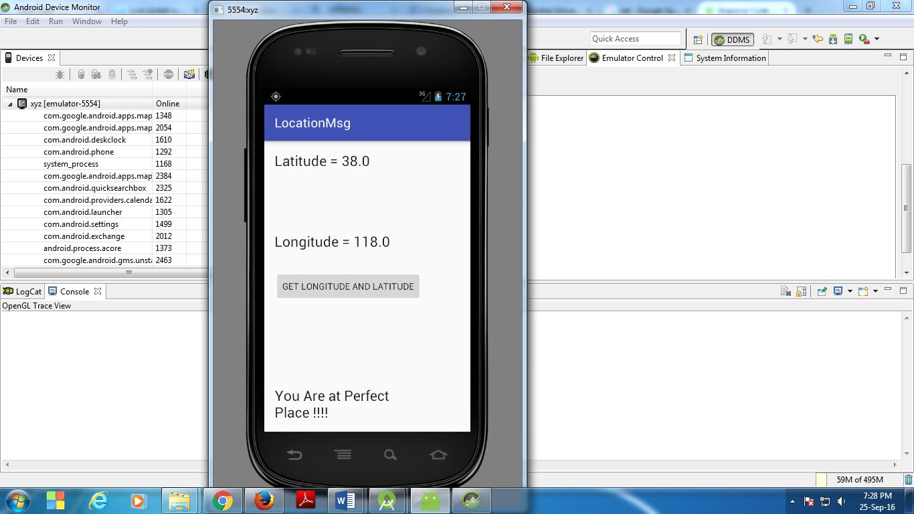
Practical No.2
Aim: - Design and develop chat messaging app which is a location-based

UI Code:-

<?xml version="1.0" encoding="utf-8"?>

<RelativeLayoutxmlns:android="http://schemas.android.com/apk/res/android"
xmlns:tools="http://schemas.android.com/tools"
android:layout_width="match_parent"
android:layout_height="match_parent"
android:paddingBottom="@dimen/activity_vertical_margin"
android:paddingLeft="@dimen/activity_horizontal_margin"
android:paddingRight="@dimen/activity_horizontal_margin"
android:paddingTop="@dimen/activity_vertical_margin"
tools:context="com.example.prashant.gpstrace.MainActivity">

<TextView
android:layout_width="wrap_content"
android:layout_height="wrap_content"
android:textAppearance="?android:attr/textAppearanceLarge"
android:text="Large Text"
android:id="@+id/textView"
android:layout_alignParentLeft="true"
android:layout_alignParentStart="true" />

<TextView
android:layout_width="wrap_content"
android:layout_height="wrap_content"
android:textAppearance="?android:attr/textAppearanceLarge"
android:text="Large Text"
android:id="@+id/textView3"
android:layout_below="@+id/textView"
android:layout_alignParentLeft="true"
android:layout_alignParentStart="true"
android:layout_marginTop="96dp" />

<Button
android:layout_width="wrap_content"
android:layout_height="wrap_content"
android:text="Get Longitude and Latitude"
android:id="@+id/button"
android:layout_centerVertical="true"
android:layout_alignParentLeft="true"
android:layout_alignParentStart="true" />

<TextView
android:layout_width="wrap_content"
android:layout_height="wrap_content"

android:textAppearance="?android:attr/textAppearanceLarge"
android:text="Large Text"
android:id="@+id/textView2"
android:layout_alignParentBottom="true"
android:layout_alignRight="@+id/button"
android:layout_alignEnd="@+id/button" />
</RelativeLayout>
Source Code:-

package com.example.prashant.gpstrace;

import android.Manifest;
import android.content.Context;
import android.content.pm.PackageManager;
import android.location.Location;
import android.location.LocationListener;
import android.location.LocationManager;
import android.support.v4.app.ActivityCompat;
import android.support.v7.app.AppCompatActivity;
import android.os.Bundle;
import android.util.Log;
import android.view.View;
import android.widget.Button;
import android.widget.TextView;

public class MainActivityextendsAppCompatActivityimplementsLocationListener {

TextViewt1, t2, t3;
Button b1;
protected LocationManagerlocationManager;
protected LocationListenerlocationListener;
double lat, longg;
@Override

protected void onCreate(Bundle savedInstanceState) { super.onCreate(savedInstanceState); setContentView(R.layout.activity_main);

t1 = (TextView) findViewById(R.id.textView);
t2 = (TextView) findViewById(R.id.textView3);
t3 = (TextView) findViewById(R.id.textView2);

b1 = (Button) findViewById(R.id.button);

b1.setOnClickListener(new View.OnClickListener() { @Override

public void onClick(View view) {
t1.setText("Latitude = " + lat);
t2.setText("Longitude = "+ longg);

if(lat<38 &&lat>36 &&longg<122 &&longg>118)
{

t3.setText("In-Side The Area");
}

else
{

t3.setText("Out-Side The Area");
}
}
});

locationManager= (LocationManager) getSystemService(Context.LOCATION_SERVICE);
if (ActivityCompat.checkSelfPermission(this,
Manifest.permission.ACCESS_FINE_LOCATION) !=
PackageManager.PERMISSION_GRANTED&&ActivityCompat.checkSelfPermission(this,
Manifest.permission.ACCESS_COARSE_LOCATION) !=
PackageManager.PERMISSION_GRANTED) {
- TODO: Consider calling
- ActivityCompat#requestPermissions
  - here to request the missing permissions, and then overriding

  - public void onRequestPermissionsResult(intrequestCode, String[] permissions,
// int[] grantResults)

  - to handle the case where the user grants the permission. See the documentation
  - for ActivityCompat#requestPermissions for more details.

return;
}

locationManager.requestLocationUpdates(LocationManager.GPS_PROVIDER, 0, 0, this);

- locationManager.requestLocationUpdates(LocationManager.GPS_PROVIDER, 0, 0, this);
}

@Override

public void onLocationChanged(Location location) {

- txtLat = (TextView) findViewById(R.id.textview1); lat=location.getLatitude();

longg= location.getLongitude(); Log.d(""+lat,""+lat); Log.d(""+longg,""+longg);

if(lat<38 &&lat>36 &&longg<122 &&longg>118)
{

t3.setText("In-Side The Area");
}

else
{

t3.setText("Out-Side The Area");
}

//t1.setText("Latitude:" + location.getLatitude() + ", Longitude:" + location.getLongitude());
}
@Override

public void onProviderDisabled(String provider) { Log.d("Latitude","disable");
}
@Override

public void onProviderEnabled(String provider) { Log.d("Latitude","enable");
}
@Override

public void onStatusChanged(String provider, intstatus, Bundle extras) { Log.d("Latitude","status");
}

}

Permission :-

<?xml version="1.0" encoding="utf-8"?>
<manifest xmlns:android="http://schemas.android.com/apk/res/android"
package="com.example.prashant.gpstrace">

<application
android:allowBackup="true"
android:icon="@mipmap/ic_launcher"
android:label="@string/app_name"
android:supportsRtl="true"
android:theme="@style/AppTheme">
<activity android:name=".MainActivity">
<intent-filter>
<action android:name="android.intent.action.MAIN" />

<category android:name="android.intent.category.LAUNCHER" />
</intent-filter>
</activity>
</application>

<uses-permission android:name="android.permission.ACCESS_FINE_LOCATION" /> <uses-permission android:name="android.permission.INTERNET" /> </manifest>
Output:-
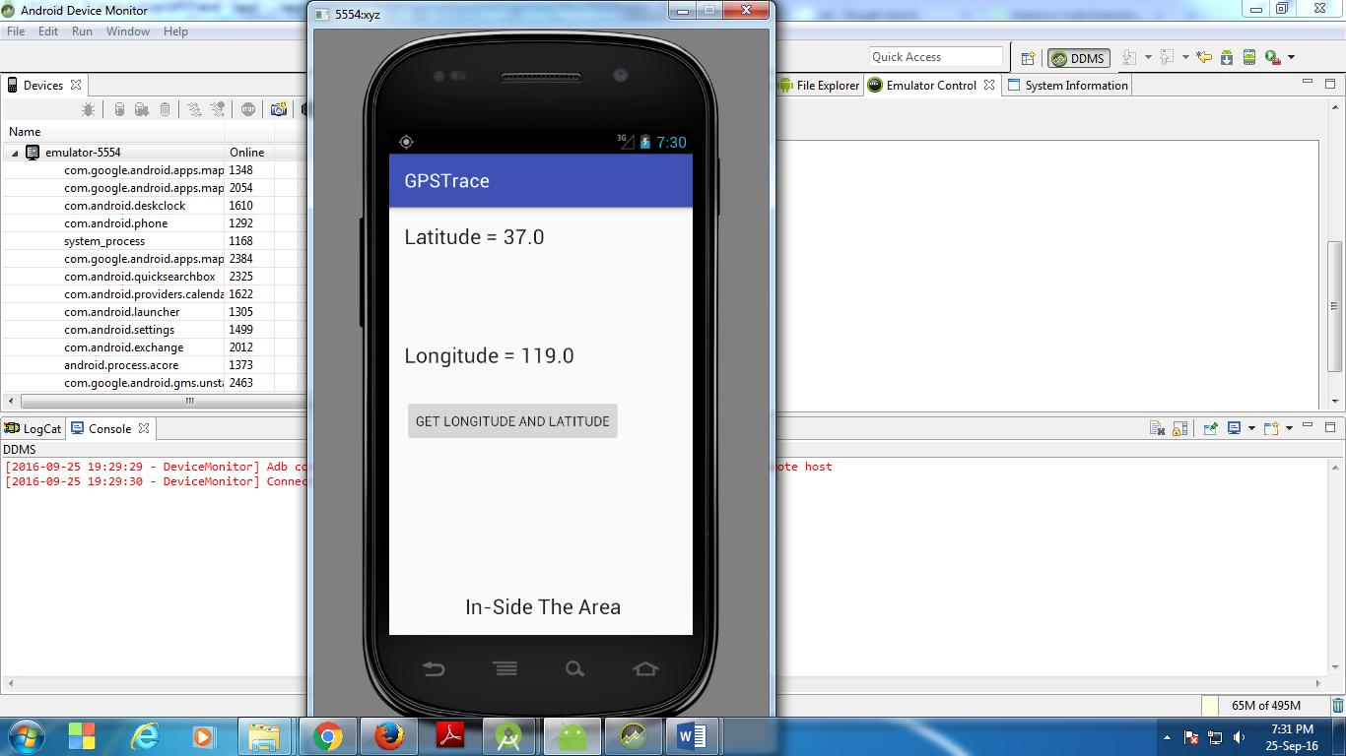
Practical No. 6
Aim: - Implementing GCM Network Manager.


MainActivity.java

package com.example.msc.gcm;

import android.support.v7.app.AppCompatActivity;
import android.os.Bundle;

import com.google.android.gms.gcm.GcmNetworkManager; import com.google.android.gms.gcm.PeriodicTask;
import com.google.android.gms.common.GoogleApiAvailability;

public class MainActivity extends AppCompatActivity {

@Override
protected void onCreate(Bundle savedInstanceState) {
super.onCreate(savedInstanceState);
setContentView(R.layout.activity_main);

GcmNetworkManager networkManager = GcmNetworkManager.getInstance(this);

PeriodicTask task = new PeriodicTask.Builder()
.setService(MyPeriodicTask.class)

.setPeriod(60)
.setFlex(30)
.setRequiresCharging(true)

.setTag("Periodic1")
.build();
networkManager.schedule(task);
}

}

MyPeriodicTask.java

package com.example.msc.gcm;

import android.app.Service;
import android.content.Intent;

import android.os.IBinder;
import android.util.Log;

import com.google.android.gms.gcm.GcmTaskService;
import com.google.android.gms.gcm.TaskParams;

public class MyPeriodicTask extends GcmTaskService

{
public MyPeriodicTask() {

}

@Override
public int onRunTask(TaskParams taskParams) {
Log.d("Debug","Running");
return 0;
}

}

AndroidManifest.xml

<?xml version="1.0" encoding="utf-8"?>

<manifest xmlns:android="http://schemas.android.com/apk/res/android"
package="com.example.msc.gcm">

<uses-permission android:name="android.permission.RECEIVE_BOOT_COMPLETED"/> <uses-permission android:name="android.permission.CHANGE_WIFI_STATE"/> <uses-permission android:name="android.permission.INTERNET"/>

<application
android:allowBackup="true"

android:icon="@mipmap/ic_launcher"
android:label="@string/app_name"
android:supportsRtl="true"
android:theme="@style/AppTheme">
<activity android:name=".MainActivity">
<intent-filter>

<action android:name="android.intent.action.MAIN" />

<category android:name="android.intent.category.LAUNCHER" /> </intent-filter>

</activity>

<service
android:name=".MyPeriodicTask"
android:enabled="false"
android:exported="true">

android:permission="com.google.android.gms.permission.BIND_NETWORK_TASK_SERVICE"> <intent-filter>

<action android:name="com.google.android.gms.gcm.ACTION_TASK_READY" /> </intent-filter>

</service>
</application>

</manifest>


build.gradle

// Top-level build file where you can add configuration options common to all sub-projects/modules.
buildscript {

repositories {
jcenter()

}
dependencies {
classpath 'com.android.tools.build:gradle:2.1.2'

- NOTE: Do not place your application dependencies here; they belong
- in the individual module build.gradle files
}
}

allprojects {
repositories {

jcenter()
}
}

task clean(type: Delete) {
delete rootProject.buildDir

}

build.gradle

apply plugin: 'com.android.application'

android {
compileSdkVersion 23

- buildToolsVersion "24.0.1" buildToolsVersion "23.0.3"

defaultConfig {
applicationId "com.example.msc.gcm"

minSdkVersion 14
targetSdkVersion 23
versionCode 1
versionName "1.0"
}
buildTypes {

release {
minifyEnabled false
proguardFiles getDefaultProguardFile('proguard-android.txt'), 'proguard-rules.pro'

}
}

}

dependencies {
compile fileTree(dir: 'libs', include: ['*.jar'])
testCompile 'junit:junit:4.12'
compile 'com.android.support:appcompat-v7:23.4.0'

//compile 'com.squareup.okhttp:okhttp:2.7.0'

compile 'com.google.android.gms:play-services-gcm:8.3.0'
}

Practical No.7
Aim: - Demonstrate use of OpenGTS (Open Source GPS Tracking System).

Settings:-

Required Software:-

- JDK 1.8
- XAMPP Server
- Mysql-java connector
- OpenGTS application.

http://www.opengts.org/

Set Environment Variables:-
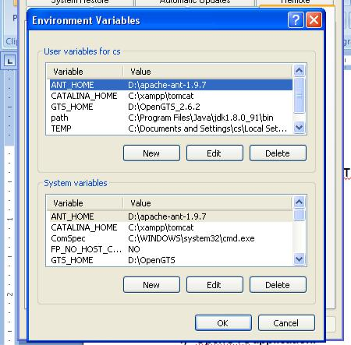

- Open command Prompt and go to C:\OpenGTS_2.6.2
- Type command ant all
- Type command ant track

- Type command ant track.deploy
- Go to C:\OpenGTS_2.6.2\bin ; Type command initdb.bat
- Type Command admin.bat Account –account:admin –pass:123456 –create
- Type url localhost:8080/track/Track and login with admin and 12345

Practical No .8

Aim: - Context-Aware system.
Context-awareness is a key concept in ubiquitous computing. The Java Context-Awareness Framework (JCAF) is a Java-based context-awareness infrastructure and programming API for creating context-aware applications

Entity:

Room.java

package dk.itu.jcafdemo.entity;

import dk.pervasive.jcaf.entity.GenericEntity;

/**

*A room in the building. A room can host events. It has a WaveTrend reader attached so it can tell

*when somebody is approaching it!

*@author mSpazzy */

public class Room extends GenericEntity {

private int floor;

private char sector;

private int room;
public Room() {

super();

}

public Room(String id) {

super(id);

}

public Room(String id, int floor, char sector, int number) { super(id);

this.floor = floor;

this.sector = sector;

this.room = number;

}
public String getEntityInfo() {

return "ITURoom entity";

}

public int getFloor() {

return floor;

}
public char getSector() {

return sector;

}

public int getRoom() {

return room;

}

public String toString() {

return "[" + getId() + "] " + floor + sector + room;

}

public String toXML() {

String context = "";
if (getContext() != null) {

context = getContext().toXML();

}

return "<room id=\"" + getId() + "\">" +

"<floor>" + getFloor() + "</floor>" +

"<sector>" + getSector() + "</sector>" +

"<room>" + getRoom() + "</room>" +

context + "</room>";

}

}

Visitor.java

package dk.itu.jcafdemo.entity;

import dk.itu.jcafdemo.item.Presentation;

import dk.pervasive.jcaf.ContextEvent;

import dk.pervasive.jcaf.ContextItem;

import dk.pervasive.jcaf.entity.Person;

public class Visitor extends Person {

public Visitor() {

super();
}

/**

Constructor for Visitor.

@param id

*/
public Visitor(String id) {

super(id);

}

/**
Constructor for Visitor.

@param id

@param name

*/

public Visitor(String id, String name) {

super(id, name);

}

@Override

public String getEntityInfo() {

return "Visitor entity";

}

@Override

public void contextChanged(ContextEvent event) {

super.contextChanged(event);
ContextItem item = event.getItem();

if(item != null) {

if(item instanceof Presentation) {

System.out.println("Name: " + getName() + " @ Presentation: " +

((Presentation)event.getItem()).getName());

} else {

} if(item instanceof Room) {

System.out.println("Name: " + getName() + " in Room: " + ((Room)event.getItem()).toString());

}

}

}

}

Item:

Presentation.java
package dk.itu.jcafdemo.item;
import dk.pervasive.jcaf.item.AbstractContextItem;
public class Presentation extends AbstractContextItem {

private String name;
public Presentation(String id, String name) {

super(id);
this.name = name;
}
public String getName() {
return name;

}

/**

TODO: implement the accuracy as needed!! */

@Override

public double getAccuracy() {

return super.getAccuracy();

}

@Override

public String toXML() {

return "<presentation id=\"" + getId() + "\">" + "<location>" + name + "</location>" + "</presentation>";

}

}
Relationship:

Arrived.java
package dk.itu.jcafdemo.relationship;
import dk.pervasive.jcaf.relationship.TimedRelationship;
public class Arrived extends TimedRelationship {

private String source;

public Arrived() {

super();

}

public Arrived(String source) {

this();

this.source = source;

}

/*

@return Returns the source. */

public String getSource() {

return source;

}
public void setSource(String source) {
this.source = source;

}
public String toXML() {
return "<arrived souce=\"" + getSource() + "\" time=\"" + getTime() + "\" />";

}

public boolean equals(Object obj) {
if (obj instanceof Arrived) {

Arrived loc = (Arrived) obj;

return loc.getSource().equals(getSource());

}

return super.equals(obj);

}

public int hashCode() {

return getSource().hashCode();

}

public String toString() {

return "arrived [" + getSource() + "]";

}

}

Attending.java
package dk.itu.jcafdemo.relationship;
import dk.pervasive.jcaf.Relationship;
/*

Relationship to connect a visitor to different ITUEvents.

@author mSpazzy*
*/

public class Attending implements Relationship {
public Attending() {

}

public String toXML() {

return "emplty";
}

}
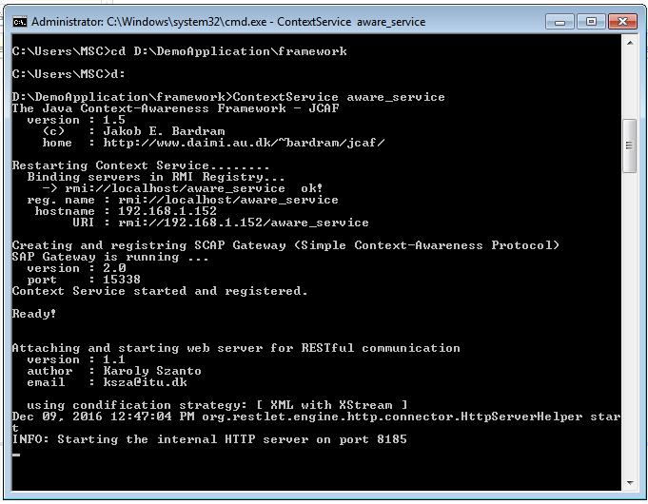
Output:

Practical No.9

Aim: - Develop application demonstrating Human Computer Interaction

SOURCE CODE:

import java.awt.*;
import java.awt.event.*;
public class CloseableSimpleWarning extends Frame implements
WindowListener {
static private final int frame_height = 150;
static private final int frame_width = 250;
public CloseableSimpleWarning() {
//setBackground(Color.red);
//setForeground(Color.black);
setTitle("Warning");
setSize(frame_width, frame_height);

addWindowListener(this); } public void windowClosing (WindowEvent e) { System.exit(0); }

public void windowClosed (WindowEvent e)
{ System.exit(0); }
public void windowIconified (WindowEvent e)
{System.exit(0); }
public void windowDeiconified (WindowEvent e)
{System.exit(0); }
public void windowOpened (WindowEvent e)
{System.exit(0);}
public void windowActivated (WindowEvent e)
{ System.exit(0); }

public void windowDeactivated (WindowEvent e)
{ System.exit(0); }
public static void main(String [] args)
{CloseableSimpleWarning f = new CloseableSimpleWarning();
f.show(); } }
Practical No. 10

Aim: - Write a Java Card applet

Download Java Card Sdk from

http://www.oracle.com/technetwork/java/embedded/javacard/downloads/jav

acard-sdk-2043229.html

Install in Netbeans as plugin :-
Tools -> Plugin
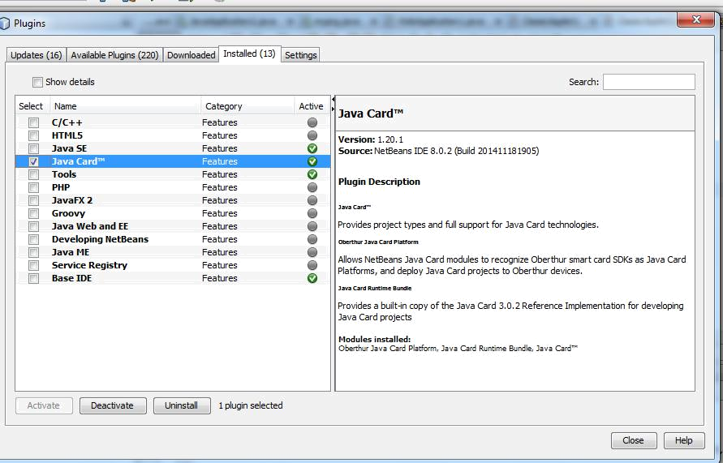

Create an application

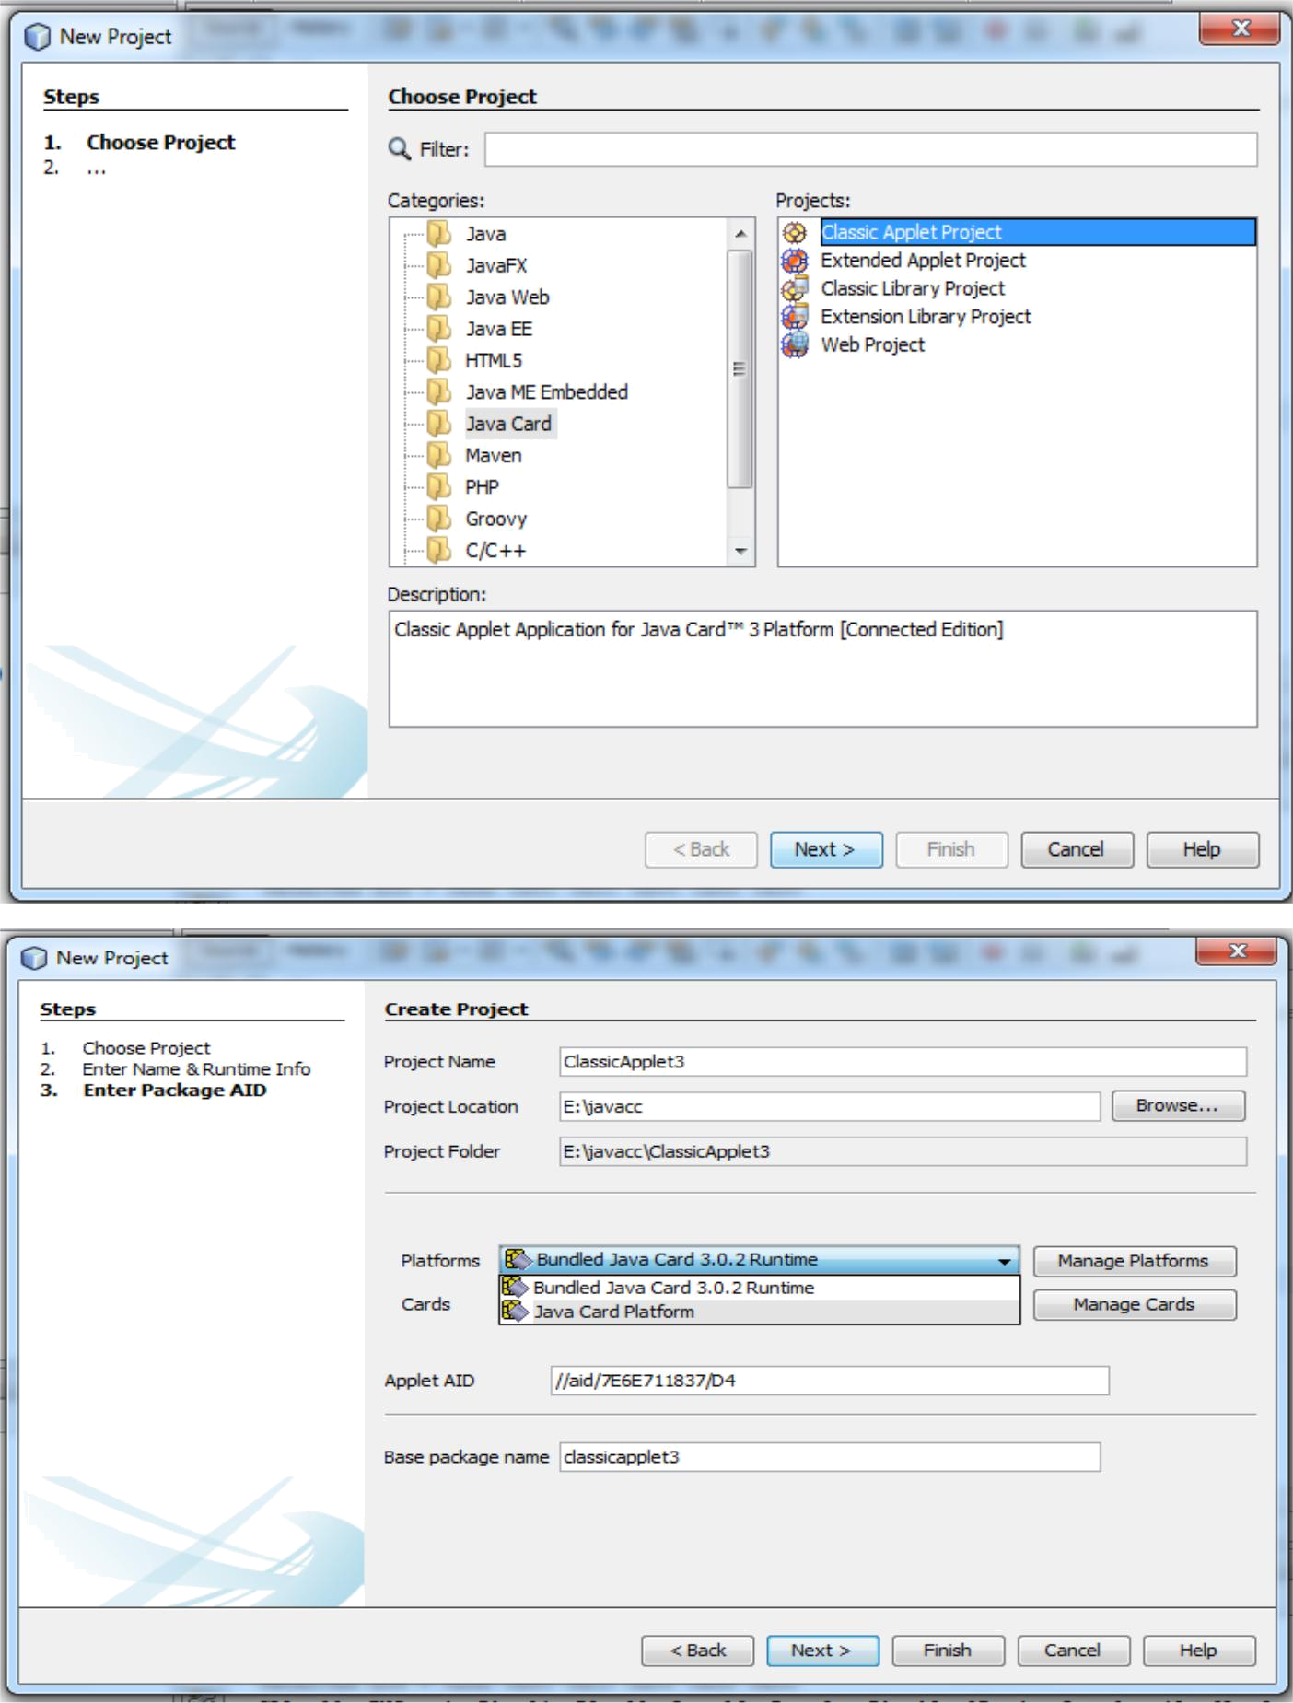

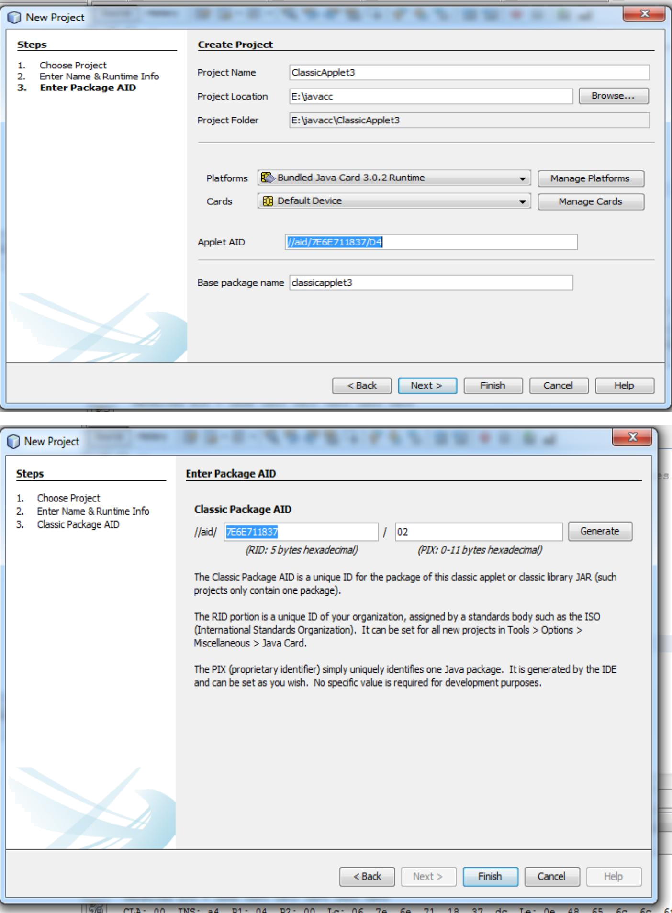

SOURCE CODE:

package classicapplet2;
import javacard.framework.*;

public class ClassicApplet2 extends Applet { private byte[] received;

private static final short MAX_LENGTH = 256; private static final byte[] helloFidesmo =
{(byte)'H',(byte)'e',(byte)'l',(byte)'l',(byte)'o',(byte)'

',(byte)'F',(byte)'i',(byte)'d',(byte)'e',(byte)'s',(byte)'m',(byte)'o',(byte)'!'}; public static void install(byte[] bArray, short bOffset, byte bLength) { new ClassicApplet2();
}

protected ClassicApplet2() {
received = new byte[MAX_LENGTH];
register();
}
public void process(APDU apdu) {
//Insert your code here
byte buffer[] = apdu.getBuffer();

short length = (short) helloFidesmo.length; Util.arrayCopyNonAtomic(helloFidesmo, (short)0, buffer, (short)0, (short)length); apdu.setOutgoingAndSend((short)0, length);

}
}

OUTPUT:
